**PARADE USER GUIDE**

**Calculations**

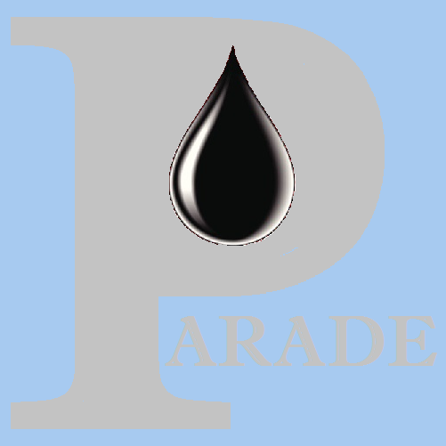

**Version 1.53 Jun 2021**

**Version History**

|  |  |  |  |
| --- | --- | --- | --- |
| **Version** | **Date** | **Author** | **Comments** |
| 1.28 | Aug 2020 | K.Wilson | Initial version |
| 1.29 | Sep 2020 | K.Wilson | Added circ profile buttons to Hydraulics |
| 1.44 | Dec 2020 | K.Wilson | Surge and Swab calculations added |
| 1.50 | Apr 2021 | K.Wilson | Overpull calculations, apparent WOB and overpull in TAD calculations, Hole cleaning/circulation in Hydraulics |
| 1.53 | Jun 2021 | K.Wilson | Hydraulic lift corrections in Torque and Drag. |

Contents

Calculation options 1

Scenario Definition 1

Scenario definition tab 2

Torque and Drag Tab 4

Drag Risk Calculation method 6

Hydraulics Tab 8

Hydraulics calculation method 11

Surge and Swab Tab 12

Surge and swab calculation method 15

The Plots Tab 16

Viewing the calculated data 17

Drag Risk at surface 17

Drag Risk Profile 18

Hydraulics risk at Surface 19

Hydraulics risk profile 20

Surge and Swab risk at Surface 20

Surge and Swab Risk Profile 21

# Calculation options

Parade provides Torque and Drag calculations, Hydraulics calculations and Surge and Swab calculations. For Torque and drag, hindcast calculations, using actual measured values of parameters are available.

Within each of these calculation types there are a number of risk calculations that can be performed.

All data is stored in oil field units and calculations are performed using formulas based on those units. These values are converted to user selected units, eg metric, when data is displayed on the screen or used in plots.

# Scenario Definition

All calculations are performed on a scenario. The scenario must be first created for the current well and then input tables defined. Then the parameters for the scenario are defined, including the Risk parameters for the calculations.

Calculations types are selected and the calculations run. These will generate output data sets, which can be viewed, and a set of standard plot definitions. These plots can then be viewed, printed and saved to a graphics file or the clipboard.

The scenario data includes physical data, as well as modelling data. Both planning and analysis scenarios can be defined.

The 3 main sets of physical data are where the well is located – the Well path – how big it is – the Hole profile - and what is in it – the String.

Usually a scenario covers just part of the well, either a hole section, as defined by the hole profile or a drilling or tripping run within a hole section, defined by the String.

If you want to compare the performance of different strings or different paths or different hole sizes you should create a new scenario for each combination.

Likewise, for fixed sets of these 3 input data files, you may want to create a separate scenario for each proposed mud type and so forth.

Parade allows both the creation of a copy of an existing scenario and the copying of different input data from other scenarios, so it is relatively quick and easy to create several different combinations of these different input datasets.

Once the scenario has been created select the Definition option on the Scenario menu and if it is not displayed by default, the Scenario Tab.

The definition screen has a number of tabs to define common parameters, to define the calculation parameters and the risk calculations to be performed for different calculation types and to view the standard plots that are created.

# Scenario definition tab

The Scenario definition tab allows you to enter data and define input data sets that are common to all calculation types.

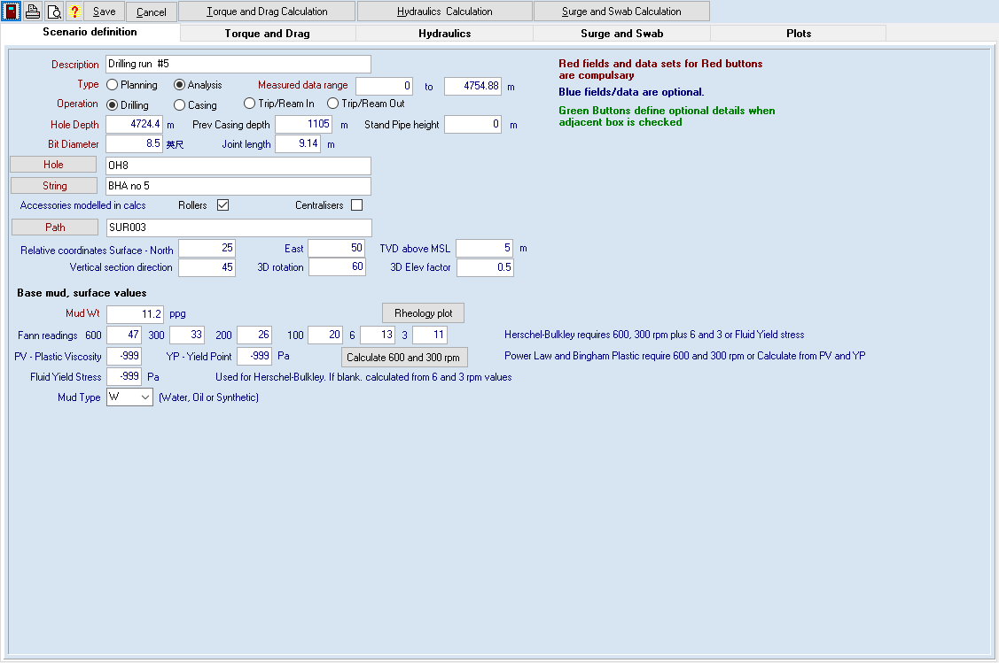

The **Description** is used as a title on reports and plots

The **Type** of scenario can be Planning or Analysis. A planning scenario uses the theoretical values to calculate curves using different risk parameters.

The Analysis scenario uses some measured values and allows the importing of Measured data from text files supplied by 3rd parties. The measured data can also be over laid on a plot of the theoretical values.

The **Operation** is either Drilling or Casing. Currently this is for the user’s information since the 2 operation types have the same calculation options.

Physical values are now entered. **Hole and casing depths, bit diameter and Joint length.**

Buttons are provided to display the forms to enter or import Hole, String and Path data and to enter a description for each of these. These tables can also be accessed from the Scenario menu directly and are described below.

Rollers and centralisers and other string attachments are defined along with the string itself. Hence a drill pipe section which has rollers on part of it must be divided into several sections in the string definition.

Path parameters are also defined here. Usually the surface coordinates are (0,0,0) and hence the path is relative to the drill floor. However, in some cases it may be desirable to define an offset, eg from a reference point on the rig.

The 3d plot parameters are also available here but are usually defined in the plot itself. **The 3d rotation value** defines the azimuth from which the plot is viewed. A good default is 90 degrees from the vertical section direction.

The **3D elevation factor** defines the ratio of the vertical distance to the horizontal distance and hence reflects the height of the viewing position. A value of 0.5 is a good default.

Next the base mud values, as measured at the surface are defined. In many cases it would be assumed that these values apply for all bit depths and are constant throughout the hole. Parade allows you to define mud variations in several ways as described below.

The **Mud wt.** and **Fan readings** at different RPM are entered. The standard rpm values used are 600,300,200,100,6,3. These values are used in the hydraulics modelling.

A mud type can also be entered.

Values and tables that have Red text are required before calculations can be run. Blue text indicates optional values and Green text indicates that the data is only required and used when a check box has been ticked.

The scenario form has 3 further tabs to define input parameters and selections for each calculation type with a calculation button above each tab, plus a final tab to display the plots.

# Torque and Drag Tab

This tab is used to enter information that is required in Torque and drag calculations

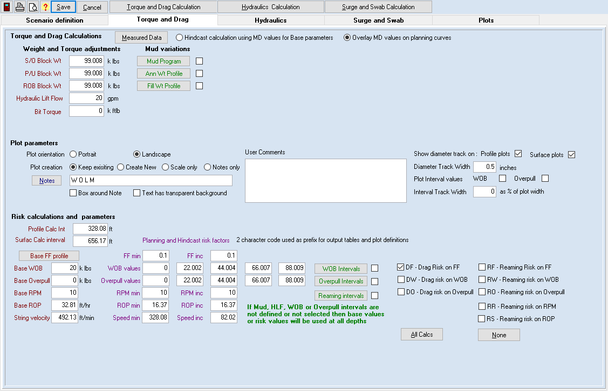

Torque and Drag calculations are used to model the tensions and torque on the drill string. This allows planning to avoid stuck pipe, twist off or being unable to reach bottom and apply weight on bit.

The green buttons and their associated check boxes allow definition and use of optional Mud variations and to define where reaming occurs.

If the box is checked, then the associated data must be defined, but it is not required when the option is not selected.

For an **Analysis** scenario, there is a button to display the measure Torque and Drag data (This is the T&D measured data option on the Scenario menu) There is also a choice of background for the actual measured data points between hindcast curves based the measured data or the planning curves using the base or risk parameters defined on this tab. If the Measured data option is selected, curves will only be calculated and displayed below the depth of the first measured data point.

**Block weights and bit torque** can then be entered. Block weights are used to convert the calculated tension values to Hookloads and bit torque can be added to the calculated torque values.

**Hydraulic lift** can be calculated by specifying the flow rate. This is independent of the base flow rate defined on the Hydraulics tab. If the flow rate is <=0, no hydraulic lift correction will be applied.

Variations in mud can be modelled by checking the boxes and defining the mud properties at different depths.

The **Mud program** indicates a change in the base mud type or its properties at a particular bit depth during drilling.

The **Mud wt profiles** indicate a change in mud properties at different depths in the hole or at different sections of the string. Eg after circulating part way through a trip or when using floated casing.

**Plot parameters** are then defined.

The **Plot orientation** can be set to Portrait or Landscape

**Plot Creation** option is selected.

This allows you to keep any manual changes you have made to an automatically generated plot, such as manual scaling, addition of curves, notes or shading or changing of colours.

* Keep existing – existing plots will not be changed, missing plots will be created
* Create New – All plots are deleted and recreated so any manual changes will be replaced with defaults.
* Scale only – Existing plots will be retained but minimum, maximum and increment values will be set to -999 and auto scaled when first displayed.
* Notes only – existing plots and their scales will be retained but the standard note will be updated in line with the Note selection and any parameter changes.

Notes can be defined by clicking on the [Notes] button. This creates a standard note consisting of selected values from the scenario definition or input data sets.

These notes can have a transparent or opaque background and can optionally be surrounded by a box.

One of the options in the note definition is to include user defined comments which are also entered in this section.

The available notes and their 1 character abbreviations are:

* G - casinG depth
* B - Block wts
* T - Topdrive
* H - Hole profile
* S - String
* F - Friction factors
* M - Mud properties
* A - Annulus wts
* P - Pipe Fill wts
* W - Weight On Bit
* O – Overpull
* L - -hydraulic Lift (flow rate)
* R - Reaming parameters
* U - User comments

**A diameter track** can be added to Profile or Surface plots, with a specified width, usually ½” or 1.25cm. This displays the hole size, and pipe size for drill string body and joints.

**An interval track** can also be added. This is only meaningful if WOB or overpull change with bit depth, as they might for measured data. Its width is defined as a % of the plot width.

The final section defines the calculation risk parameters and selects which calculations are to be performed.

The **Profile Calculation Interval** determines the frequency and size of the intervals used in calculating the values for a particular bit depth. Since the Torque and Drag calculation is iterative this size affects the results and the speed of the calculation to some extent.

For each calculation interval, the bottom values for the calculation are the top values from the previous section. A small interval such as 10 feet gives a more accurate result than 100 ft, but takes longer to calculate, display and plot.

The **Surface Calculation Interval** defines how many profile calculations occur since each record in that table is the final value of a separate profile calculation. This does not need to be too small since it only needs to be sufficient to provide a smooth plot. Usually 100 or 200 ft (50 or 100m) is acceptable.

There are a number of risk factors that can be modelled. Each of these must have a base value defined to be used in the other risk calculations plus 5 values that vary for the risk calculation itself.

**The Base FF profile** defines the Slack off, Pick up and Torque friction factors in different sections of the hole and whether these vary in the FF risk calculation. Usually there are 2 sections corresponding to the cased and open hole sections. FF risk is usually applied to the open hole and optionally to the cased hole. The 5 FF risk factors are defined by a start value and an increment.

**The Base WOB** value is the Weight on Bit used in the FF risk and other calculation types. For the WOB risk calculation 5 values are defined, which do not need to be evenly spaced. WOB intervals can be turned on and applied. This table defines the WOB values for different bit depths, similar to the variation that might be seen in measured data. If not turned on, then the base or risk values are used at all bit depths.

**The Base Overpull** value is the Overpull used in the FF risk and other calculation types. For the Overpull risk calculation 5 values are defined, which do not need to be evenly spaced. Overpull can likewise be defined at different bit depths.

**Base RPM and Base ROP or String Velocity** are used when reaming occurs or is modelled. The 5 risk factors are defined by a start value and an increment. ROP is used in drilling scenarios and is usually measure in length per hour whereas Trip speed is used for tripping and casing runs and is measured in length per minute. Reaming intervals can be turned on to defined the ROP and rpm used at different bit depths.

There are 2 groups of Torque and Drag calculations. The Drag risk applies when drilling and Reaming risk applies when rotating during a trip or casing run. Hence both types have FF, WOB and Overpull risk calculations and Reaming also allows for risk on RPM and ROP or String velocity.

Calculations to be performed are selected by check boxes with options to turn all of these on or off.

To actually run the calculations, click on the [Torque and Drag Calculation] button.

# Drag Risk Calculation method

The drag risk calculation is an iterative calculation. In the profile calculation, calculation points are defined as multiples of the profile calculation interval plus additional points for casing depth, TD and any depths where the input parameters change, eg depths for tops of string items.

Initial forces at the bit are set from WOB, Overpull and bit impact force. The changes in values for each section are calculated and these are dependent on the values at the bottom of the section and the path, as well as the parameters for string, hole, mud, friction factor etc for the section. If a hydraulic lift flow is defined, the viscous drag over the sections is defined and subtracted from the change in tension, since this acts as an upthrust. The values at the top of each section are calculated by adding the changes to the bottom values and the next section upwards is then processed.

The values for each profile calculation at the surface are then saved for that bit depth in the surface values table.

The values at each calculation depth are saved in the Profile table for the calculation at TD. However, it is possible to run a profile calculation at other depths and view the results in the table or in a plot. The Depth plot screen allows different depths to be entered for a profile plot and a “movie” to be run where calculations are made and the plot displayed at regular increase in depth.

The calculated values include Tensions (which can be displayed as Hookloads), Torques, Normal Force, Buckling values, Stretch, Wraps and Standoff.

The plots of planning data can be used to check values during drilling. Significant departures from the planned values may be a warning of hole problems.

The usual measurements during drilling are made after each joint is drilled. The **Pickup weights** are measured when the string is being slowly raised and the **slack off weights** when it is lowered, usually without string rotation and off bottom torque values are measure during rotation while the string is stationary. The rotating friction factor is set to a small value (0.001) since the main issue is torque.

The calculated values for **Rotating down** and **Rotating up** are the Rotating off bottom values with WOB and Overpull applied respectively. On the rig these would correspond to measurements when rotating on bottom and when pulling up slowly while rotating with overpull. (ie string movement is small and reaming correction to friction factors are not applied)

During a trip or casing the pick up or slack off values are usually measured once the drill string has reached a steady rate of movement to avoid acceleration or deceleration factors.

In reaming risk calculations, the Pick Up, Slack off and Torque Friction factors are modified based on the ROP and RPM. Otherwise, the calculation algorithm is the same as for drag risk. In this case the rig measurements should be made while the string is moving and rotating.

Apparent WOB is calculated for each risk factor by first running the calculation with 0 WOB. The results of this calculation are then subtracted from the results with the WOB applied to get the difference. This difference is the apparent WOB as seen at surface, which is usually different from the actual WOB applied at the bit.

In a similar manner, a calculation with 0 overpull is first run and the values compared with the calculations with overpull applied, to determine the apparent overpull.

*Note that Pick up values are calculated with WOB and Slack off values with overpull, but these values are essentially meaningless and are not plotted. They do, however, still appear in the table.*

# Hydraulics Tab

This tab is used to enter information that is required in Hydraulics Calculations

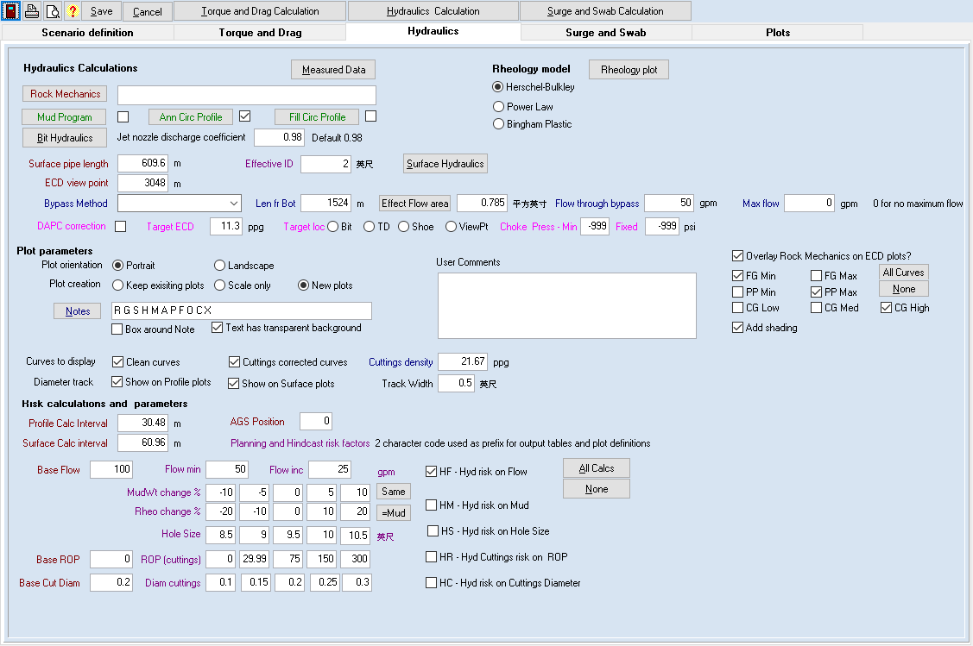

The main purpose of Hydraulics calculations is to model the effect of pump flow rate and mud properties on the pressures in the hole and their equivalent circulating densities (ECD). These often need to be controlled to prevent Kicks, Formation collapse or Fracturing.

The green buttons and their associated check boxes allow definition and use of optional Mud variations. If the box is checked, then the associated data must be defined, but it is not required when the option is not selected.

The **mud program** indicates a change in the mud type or its properties at a particular depth during drilling.

The **circulation profiles** define how mud properties vary as the mud circulates though the pipe and annulus, eg due to temperature or pressure affects.

There are buttons to run the **[Bit Hydraulics]** and **[Surface Hydraulics]** calculations which are also available on the Toolbox Menu.

The [**Rock Mechanics]** button displays the Rock Mechanics table, which is also available on the Scenario Menu. If data is entered is can be displayed on ECD plots as an overlay.

There are 3 **Rheology models** that can be used, based on the 2017 edition of API 13D – Herschel-Bulkley is currently the standard model, with the Power Law and Bingham Plastic models now being special cases.

The pressure losses through the bitare calculated from nozzle sizes as defined in the string. The **[Bit Hydraulics]** button displays a pop up that can perform EFA and bit performance calculations. A **discharge factor,** with a default of 0.98, can be used to indicate the efficiency of these nozzles.

The **pressure losses at surface** are calculated from the length of the surface pipe and its (Effective) Internal diameter.

In the Profile calculation, ECDs are calculated at certain critical points, the bit, the shoe, TD and a user defined **viewpoint**. The values are saved in the surface table for the particular bit calculation depth.

If a **Bypass** valve is present, the flow through the bypass and below the bypass can be modelled. Normally a balanced pressure calculation is made, whereby the flow split between the bypass and the string is such that the pressure through the bypass matches the pressure down the pipe, through the bit and up the annulus to the bypass depth. However, the selection also allows a fixed % of the flow through the bypass or a fix flow rate to be modelled. The Method and position in the string are defined and the effective flow area, which can be calculated from Nozzle size. The flow % or rate is then defined depending on the method selected and a maximum flow rate through the bypass can be set.

A **Direct Annulus Pressure Correction (DPAC)** can also be modelled. In this case, additional pressure is applied at surface, to generate a Target ECD at a particular location – one of the 4 defined for the ECD calculations. This is done by adjusting a choke, and the minimum and/or fixed pressures can also be defined.

**Plot parameters** are then defined.

The **Plot orientation** can be set to Portrait or Landscape

**Plot Creation** option is selected.

This allows you to keep any manual changes you have made to an automatically generated plot, such as manual scaling, addition of curves, notes or shading or changing of colours.

* Keep existing – existing plots will not be changed, missing plots will be created
* Create New – All plots are deleted and recreated so any manual changes will be replaced with defaults.
* Scale only – Existing plots will be retained but minimum, maximum and increment values will be set to -999 and auto scaled when first displayed.
* Notes only – existing plots and their scales will be retained but the standard note will be updated in line with the Note selection and any parameter changes.

**Notes** can be defined by clicking on the [Notes] button. These create a standard note consisting of selected values from the scenario definition or input data sets.

These notes can have a transparent or opaque background and can optionally be surrounded by a box.

One of the options in the note definition is to include user defined comments which are also entered in this section.

The available notes and their 1-character abbreviations are:

* R - Rheology model
* G - casing depth
* H - Hole profile
* S - String
* M - Mud properties
* A - Annulus Circ Prof
* P - Pipe Circ Prof
* F - Flow Rate
* D - DAPC
* B - Bypass
* O- cuttings ROP
* C- Cuttings diameter
* X - Surface Pipe
* U - User comments

If **Rock mechanics** have been defined the curves can be overlayed on ECD plots. The overlay can be turned on or off and the curves to be included selected by check boxes. In addition, shading can be applied to the selected curves, shading from Collapse gradient and Pore pressure going to the left of the plot and Fracture gradient to the right.

Both or either of the **clean and cuttings** affected curves can be displayed

**A diameter track** can be added to Profile or Surface plots, with a specified width, usually ½” or 1.25cm. This displays the hole size, and pipe size for tube and joints.

The final section defines the calculation risk parameters and selects which calculations are to be performed.

The **Profile Calculation Interval** determines the frequency and size of the intervals used in calculating the values for a particular bit depth. Since the Hydraulics calculation are performed on sections where the string or hole values changed this only defines the interpolation interval for plotting and does not impact on the accuracy of the results. Hence 100 or 200ft is usually small enough. results to some extent.

The **Surface Calculation Interval** defines how many profile calculations occur since each record in that table is the final value of a separate profile calculation. This does not need to be too small since it only needs to be sufficient to provide a smooth plot. Usually 100 or 200 ft is acceptable.

There are a number of risk factors that can be modelled. Each of these must have a base value defined to be used in the other risk calculations plus 5 values that vary for the risk calculation itself.

**The Base Flow rate** defines the flow value used in the other risk calculations. The 5 Flow rate risk factors are defined by a start value and an increment and are used with the base values of the other parameters.

**Mud sensitivity** is modelled by applying % change to the base mud and base Rheology values independently. So, you could model Rheology changes for a fixed mud weight and vice versa or vary both.

**Base ROP** is used when cutting impact is modelled with 5 risk values for the ROP risk calculation.

**Base Cutting diameter** is used for hole cleaning calculations and risk values are used in the cuttings diameter risk calculation.

Calculations to be performed are selected by check boxes with options to turn all of these on or off.

To actually run the calculations, click on the [Hydraulics Calculation] button.

# Hydraulics calculation method

For hydraulics calculations, the hole and the string are divided into section of constant values and the pressure losses per foot calculated for each section independently.

For each section the length is divided into tubing, tool joints, bladed items, HCAs etc and the pressure los per foot for each of these is calculated separately. These are then combined on a prorate basis to get an overall pressure loss per foot.

The pressure calculations also determine the flow regime and for non-turbulent flow a rotation factor is applied and, when present, a HCA improvement factor.

**For a bypass calculation**, a fixed flow split is applied or calculated from a fixed % of the flow rate where appropriate. The section of the hole below the bypass uses the reduce flow rate in its calculations and the pressure loss through the bypass is applied at the bypass depth.

For the balanced pressure method, initial flow splits are set to 0 and 50% through the bypass and then the program iterates to find the split that gives a balance between pressure los below the bypass and through it.

**When DAPC is applied**, after calculating the ECDs from pressure loss, the additional ECD to meet the target at the target depth is determined and converted to a pressure. The calculated values are then adjusted by this amount.

The profile pressure losses at each calculation depth, are then determined by summing the pressure losses using the pressure loss per foot for each section and the section lengths.

The surface values at each calculation depth are saved to the surface table.

# Surge and Swab Tab

This tab is used to enter information that is required in Surge and Swab Calculations

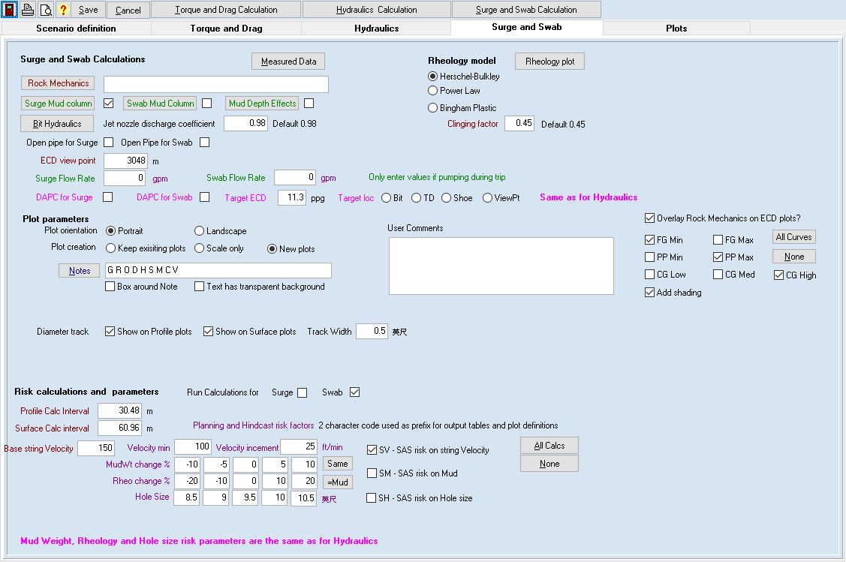

Surge and swab calculations are used to model Hydraulics during pipe movement, eg tripping in or out or running casing. There can also be instantaneous surge and swab pressure during connections.

As for the hydraulics calculations, pressures and ECDs may need to be controlled.

The green buttons and their associated check boxes allow definition and use of optional Mud variations. If the box is checked, then the associated data must be defined, but it is not required when the option is not selected.

The **mud columns** indicate a change in the mud type or its properties at a particular depth during tripping. The assumption for the Swab mud column is that the mud changes during the trip out at particular depths, eg due to circulating out, and that the mud properties for each section apply from the bottom depth to the surface. For a surge mud column, the assumption is that the hole had multiple layers of mud before the trip started, rather than changing during the trip. Once the string enters a new mud section, its top will be displaced upwards by the volume of pipe below it. It is assuming that, for open pipe the depth inside and outside the string are the same.

The **Depth effects** define how mud properties vary along the pipe and annulus, eg due to temperature or pressure affects. It is assumed that the same changes apply to mud inside and outside the string.

There are buttons to run the **[Bit Hydraulics]** calculations which are also available on the Toolbox Menu.

The [**Rock Mechanics]** button displays the Rock Mechanics table, which is also available on the Scenario Menu. If data is entered is can be displayed on ECD plots as an overlay.

There are 3 **Rheology models** that can be used, based on the 2017 edition of API 13D – Herschel-Bulkley is currently the standard model, with the Power Law and Bigham Plastic models now being special cases. In addition to flow caused by the displacement of the string, and additional component is caused by the mud clinging to the pipe. The **Clinging factor** is used to calculate this and has a default of 0.45.

The pressure losses through the bitare calculated from nozzle sizes as defined in the string. The **[Bit Hydraulics]** button displays a pop up that can perform EFA and bit performance calculations. A **discharge factor** with a default of 0.98 can be used to indicate the efficiency of these nozzles.

In the Profile calculation, ECDs are calculated at certain critical points, the bit, the shoe, TD and a user defined **viewpoint**. The values are saved in the surface table for the particular bit calculation depth. The viewpoint for Hydraulics Calculations and Surge and Swab calculations are the same.

If pumps are used during either Surge or Swab calculations, the addition **Flow Rate** from pumping can be entered.

A **Direct Annulus Pressure Correction (DPAC)** can also be modelled. In this case additional pressure is applied to generate a Target ECD at a particular location – one of the 4 defined for the ECD calculations. This can be turned on separately for Surge calculations and swab calculations

**Plot parameters** are then defined.

The **Plot orientation** can be set to Portrait or Landscape

**Plot Creation** option is selected.

This allows you to keep any manual changes you have made to an automatically generated plot, such as manual scaling, addition of curves, or shading or changing of colours.

* Keep existing – existing plots will not be changed, missing plots will be created
* Create New – All plots are deleted and recreated so any manual changes will be replaced with defaults.
* Scale only – Existing plots will be retained but minimum, maximum and increment values will be set to -999 and auto scaled when first displayed.
* Notes only – existing plots and their scales will be retained but the standard note will be updated in line with the Note selection and any parameter changes.

**Notes** can be defined by clicking on the [Notes] button. These create a standard note consisting of selected values from the scenario definition or input data sets.

These notes can have a transparent or opaque background and can optionally be surrounded by a box.

One of the options in the note definition is to include user defined comments which are also entered in this section.

The available notes and their 1-character abbreviations are:

* R - Rheology model
* G - casinG depth
* H - Hole profile
* S - String
* M - Mud properties
* C - mud Column
* E – mud depth Effects
* F - Flow Rate
* V – string Velocity
* O – Open pipe
* D - DAPC
* U - User comments

If **Rock mechanics** have been defined the curves can be overlayed on ECD plots. The overlay can be turned on or off and the curves to be included selected by check boxes. In addition, shading can be applied to the selected curves, shading from Collapse gradient and Pore pressure going to the left of the plot and Fracture gradient to the right.

**A diameter track** can be added to Profile or Surface plots, with a specified width, usually ½” or 1.25cm. This displays the hole size, and pipe size for tube and joints.

The final section defines the **calculation risk parameters** and selects which calculations are to be performed.

Both or either of the **Surge and Swab calculations** can be run and the calculated curves added to the standard plots.

The **Profile Calculation Interval** determines the frequency and size of the intervals used in calculating the values for a particular bit depth. Since the calculations are performed on sections where the mud, string or hole values changed this only defines the interpolation interval for plotting and does not impact on the accuracy of the results. Hence 100 or 200ft is usually small enough.

The **Surface Calculation Interval** defines how many profile calculations occur. since each record in that table is the final value of a separate profile calculation. This does not need to be too small since it only needs to be sufficient to provide a smooth plot. Usually 100 or 200 ft is acceptable.

There are a number of risk factors that can be modelled. Each of these must have a base value defined to be used in the other risk calculations plus 5 values that vary for the risk calculation itself.

**The Base String Velocity** defines the value used in the other risk calculations. The 5 risk factors are defined by a start value and an increment and are used with the base values of the other parameters.

**Mud sensitivity** is modelled by applying % change to the base mud and base Rheology values independently. So, you could model Rheology changes for a fixed mud weight and vice versa or vary both.

**Hole size sensitivity** uses 5 holes sizes with the base mud and velocity values. These sizes are only applied to hole sections where the Calculation risk flag is turned on.

Calculations to be performed are selected by check boxes with options to turn all of these on or off.

To actually run the calculations, click on the [Surge and Swab Calculation] button.

# Surge and swab calculation method

For Surge and Swab calculations, the hole and the string are divided into sections of constant values and the pressure losses per foot calculated for each section independently.

For each section the length is divided into tubing, tool joints, bladed items, HCAs etc and the pressure los per foot for each of these is calculated separately. These are then combined on a pro rata basis to get an overall pressure loss per foot.

**The effective flow rate** used in the calculation is calculated from the string item size and the string velocity.

**For a closed string** the external volume of the string is used to calculate the volume displaced and the Velocity converts this to a flow rate

**For an open string,** an iterative procedure similar to the bypass calculation is performed do determine the flow split into the annulus and inside the pipe.

The pressure calculations also determine the flow regime and for non-turbulent flow a rotation factor is applied and when present an HCA improvement factor.

**For a bypass calculation**, a fixed flow split is applied or calculated from a fixed % of the flow rate where appropriate. The section of the hole below the bypass uses the reduce flow rate in its calculations and the pressure loss through the bypass is applied at the bypass depth.

For the balanced pressure method, initial flow splits are set to 0 and 50% through the bypass and then the program iterates to find the split that gives a balance between pressure los below the bypass and through it.

**When DAPC is applied**, after calculating the ECDs from pressure loss, the additional ECD to meet the target at the target depth is determined and converted to a pressure. The calculated values are then adjusted by this amount.

The profile pressure losses at each calculation depth, are then determined by summing the pressure losses using the pressure loss per foot for each section and the section lengths.

The surface values at each calculation depth are saved to the surface table.

# The Plots Tab

This tab allows quick selection of the automatically generated plots from the calculations and is essentially the same as the Plot selection form on the Graphics menu.

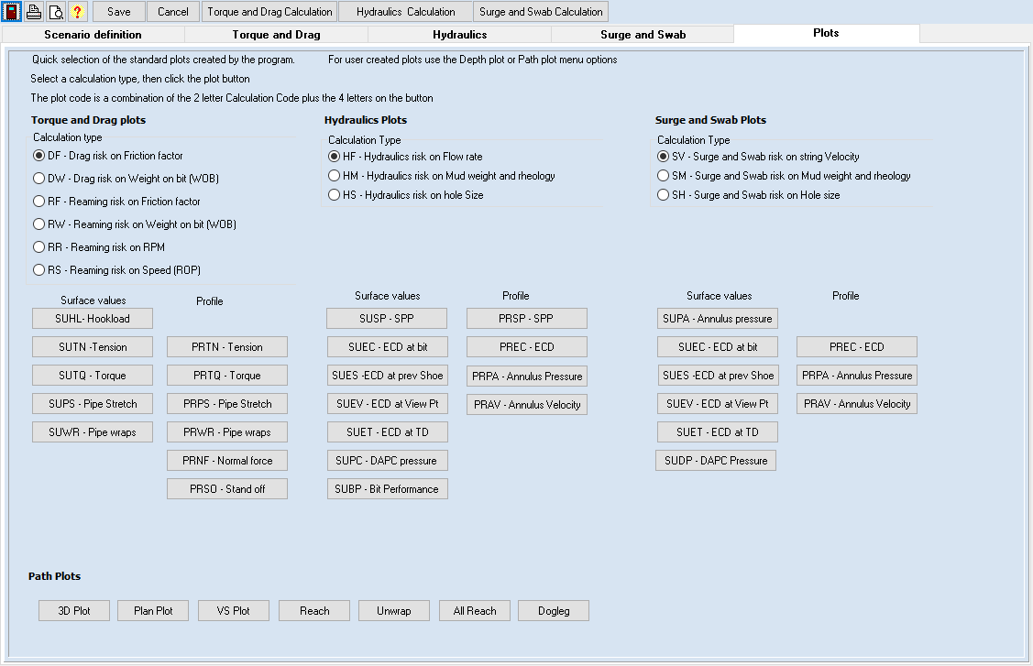

There are 3 sets of plots that can be selected. For plots created in the Torque and drag, Hydraulics, and Surge and Swab calculations, you first select the risk factor for the calculation type using the radio buttons and then click on the button for the plot type to be displayed.

The Path plots can also be displayed from this screen.

Although the most common way of displaying the data is via a plot, the underlying values can also be viewed in tables using options on the **Calculated data** menu.

# Viewing the calculated data

There are 2 sets of calculated data for each calculation type and risk factor.

The **Profile calculation** determines values for various parameters at different depths along the hole for a fixed bit depth.

For each profile calculation, the values at the surface are added to the corresponding **Surface calculation** table with the depth for each record being the bit depth for the profile calculation.

The tables of these calculated results can be accessed via the **Calculated data** menu

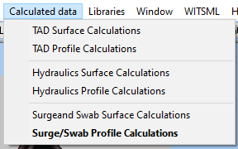

## Drag Risk at surface

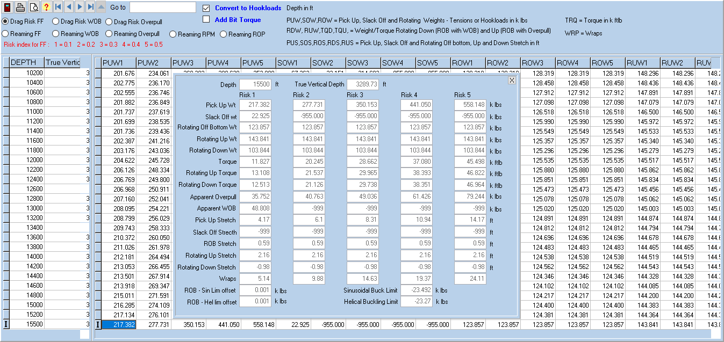

At the top of the screen there are radio buttons that are used to select the Risk calculation for which the data is displayed and below that in red, the 5 risk values applied.

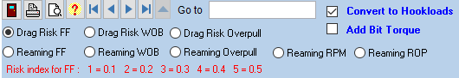

The grid and the edit form just use the Risk number as labels, eg PUW5 in this case would be the Pick up Weight for FF=0.5.

For the Surface Drag Risk table tensions can be converted to Hookloads by adding block weights and Bit Torque can be added to the torque values by clicking in the check boxes.

The abbreviations in the grid headers and the units used are also listed in the top section.

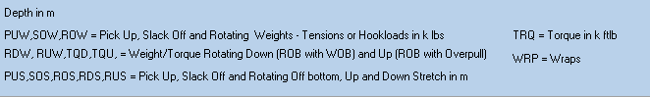

Usually Surface calculations are run with calculation intervals sufficiently small to give a smooth plot and since, each record in the table is a separate set of profile calculations, this is generally saved and loaded from file.

## Drag Risk Profile

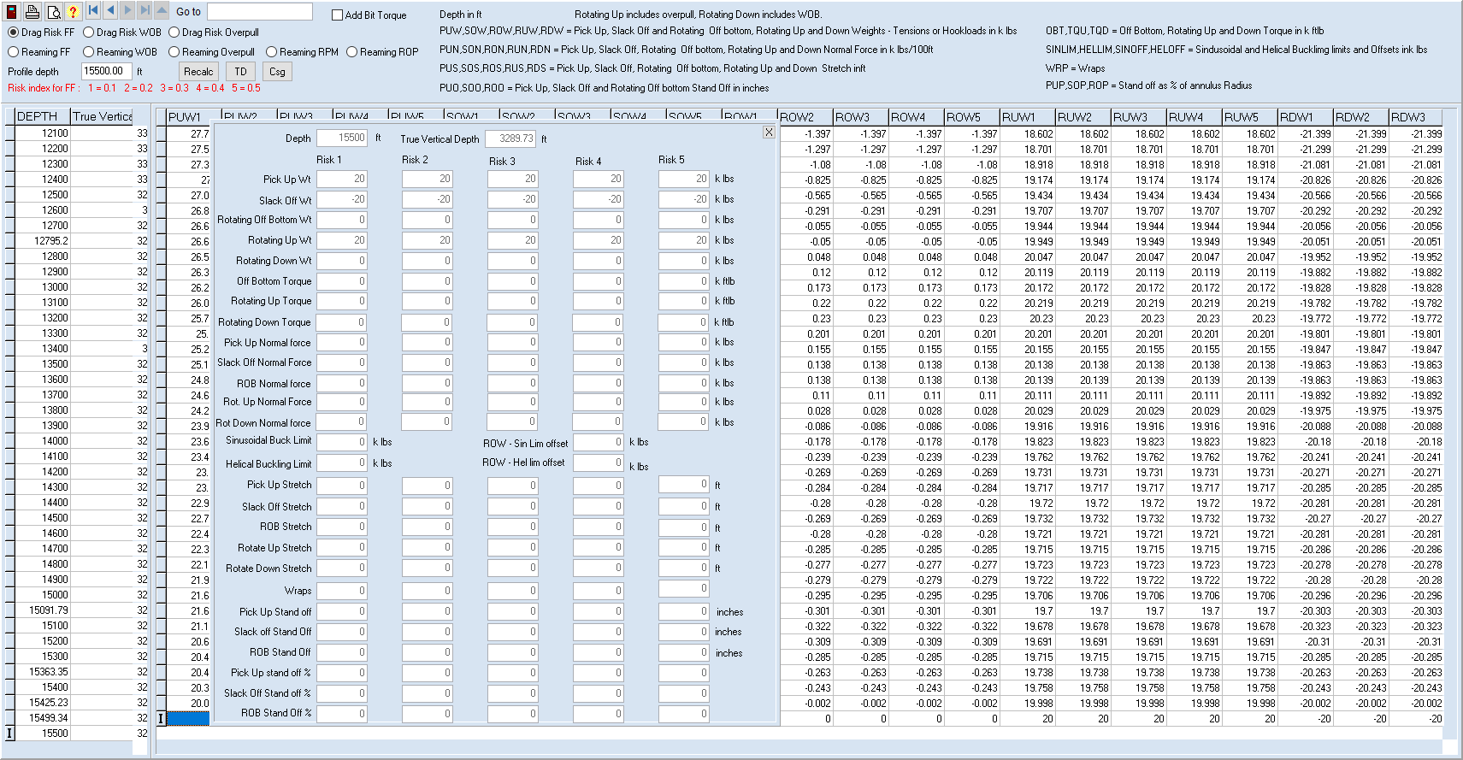

The profile form, likewise has a set of radio buttons to select the risk calculation results and to add bit torque.

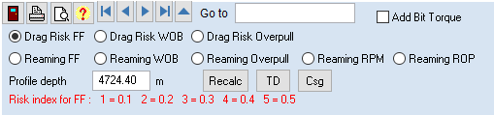

In addition, there is an option to change the depth at which the profile is calculated, with shortcut buttons to perform this at the Casing shoe {Csg] or at [TD]

Since the calculation interval impacts on the accuracy of the results, the profile table may have a large number of records, each of which has a large number of fields.

Because of this it can take much longer to load the data from file that it takes to actually calculate it and so, if the calculation has not already been run since the program and scenario were loaded, the calculation will be performed. Note this also happens for the first time a profile is plotted. There is a barely perceptible delay while this calculation is performed.

There is also a description of the column header abbreviations and units.

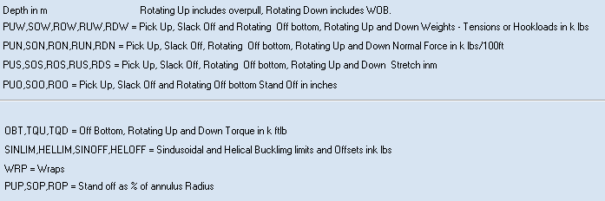

## Hydraulics risk at Surface

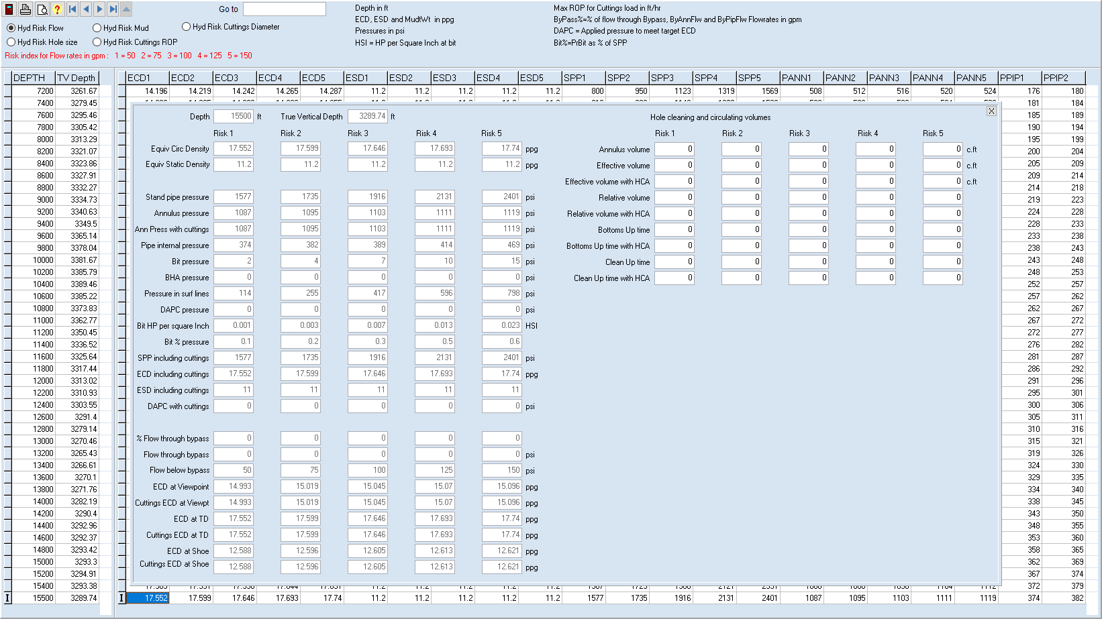

This table also has radio buttons for selection the risk calculation.

## Hydraulics risk profile

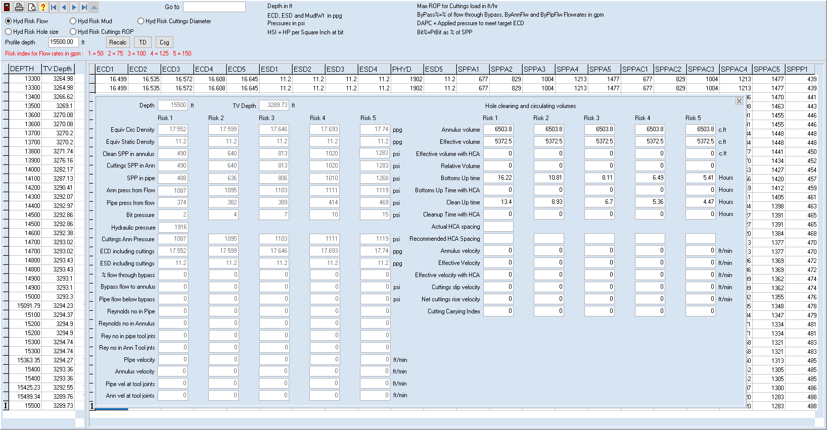

This table again allows you to select the risk factor results and to recalculate the profile at different depths.

## Surge and Swab risk at Surface

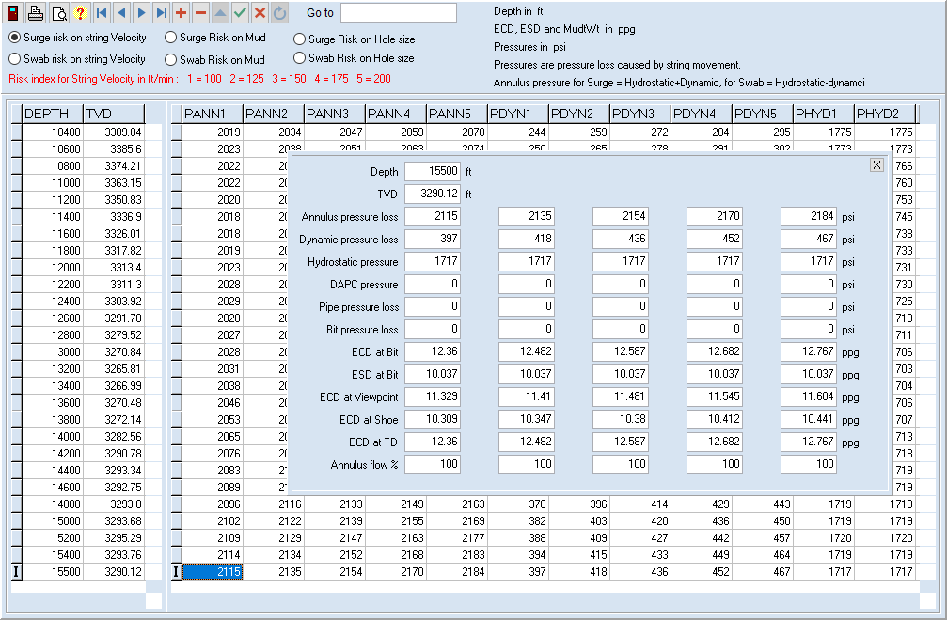

In this form, the Surge calculations and the Swab calculations for each risk type are displayed in separate tables.

## Surge and Swab Risk Profile

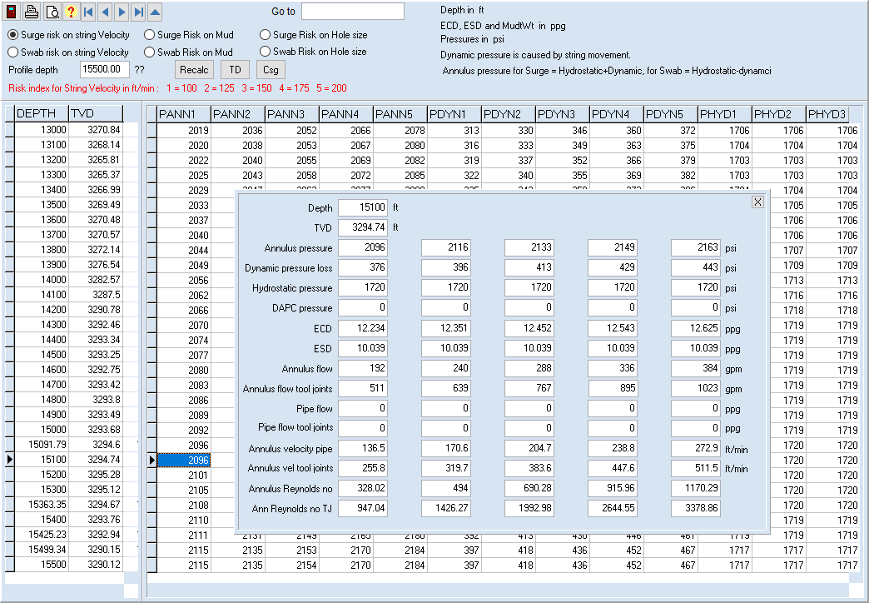

In this form, the Surge calculations and the Swab calculations for each risk type are displayed in separate tables.

In addition, there is an option to change the depth at which the profile is calculated, with shortcut buttons to perform this at the Casing shoe {Csg] or at [TD]